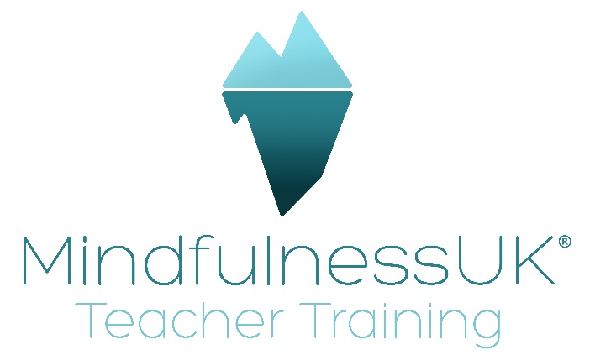
Creating a Compassionate and Safe Space in Your Mindful Movement Group Sessions

- Assessment
Assessing each participant gives a 2-way opportunity to create safety. One for you as the teacher to ensure your instructions can be modified to meet the individual’s needs and also for them to be able to meet you and ask questions. The sense of safety starts with this initial meeting so give space and time for trust to emerge.
- Know Yourself
It’s imperative that you know what it feels like to move mindfully with compassion. Know your owns patterns as these will translate to your instructions. Be grounded and present with whatever is here for you and those you’re teaching. Be aware of how you are feeling and know that this might not be the same for everyone ie you may wish to stretch and balance on one leg but your participants may need a softer approach today, or vice versa. Teach what you know, of yourself and of the practices. Don’t overextend your instructions beyond your knowledge and experience as this will not be safe for anyone. It’s important that you have done your own work, particularly if you’re holding onto trauma which is deep-seated in the body otherwise this will show up in your teaching and take the emphasis away from your participants.
- Setting up the space
There are different considerations for teaching online and in a venue. First and foremost, know as much about them as possible and introduce yourself if it’s a new group or there’s a new member. Explain the “house rules” to orientate them to the space and group eg taking care, going at your own pace, asking for help if required, pausing if necessary, using the props provided, having water etc. Invite them to say hello to the person or people next to them to enable them to feel comfortable and connected from the outset, thereby soothing their system and giving them a sense of belonging.
Online
You may wish to let them know what they will need to bring to ensure their safety and comfort. Advice on improvised mats, blocks, bolsters etc using pillows and cushions etc might be helpful. A camera that ensures all of you can be seen is essential and also that you can see the participants easily. They also need to be able to hear your instructions clearly so an external mic can be useful, such as Zoom (not related to zoom the platform).
Venue
Ensure everyone knows where they are coming and whether they need to bring anything with them. Set up early, creating a warm, inviting and comfortable space with all the props required, drinks and anything else you’ll need for the session.
Ground yourself before people arrive and be welcoming and accommodating. All the while you can be observing how they choose their space, how they move, their interactions or lack of them with others, how they appear with their pallor, what they’re wearing, energetically and so on. All the non-verbal cues will give you lots of insights into what’s going on for them right now.

- Giving instructions
Consider your language when giving instructions, ensuring it’s clear and easily understood by all. This is a perceptual experience and there’s no need to become heady and conceptual as this negates their physiological experiences. Be sure to offer choices with whether the eyes are open or closed, what to do with the breath during movement, perhaps ask them to sigh the breath out to create some vocalisations. This has the added benefit of extending the outbreath and stimulating the parasympathetic nervous system. Remember that those who have suffered with trauma may find controlled breathwork activating or immobilising (polyvagal theory) so keep the instructions light and spacious.
Always ground first this will help you as the teacher to stay present but also it creates a sense of connection to themselves and also other who share that ground. Allow the floor, ground, earth, universe to support them as they surrender their weight up to this support.
There’s no pushing, striving, competition- bring the 8 attitudes into your vocabulary if it helps.

- The Iceberg Model
It can be helpful to follow these 6 processes when leading mindful movement, starting with the development of awareness, followed by noticing, integration, self-soothing, changing habits and then sustaining these changes compassionately through regular practice and the group.

- Working with pain
Chronic pain manifests often due to trauma, perhaps from decades ago so take it slowly and repeat instructions. These participants will have a great deal of complexities, physically, mentally and emotionally so they don’t need these added to with timings, specific aligned postures and complicated sequences. They need to feel safe and in control at all times and it’s the teacher’s responsibility to create this spacious and kind environment so that it echoes for them internally. When working the body, often emotions bubble up and provision must be made for this with tissues, a sense of it’s OK, asking what they need right now to support themselves, offering a glass of water to ground them again and enabling them to come out of their body for a few moments to recalibrate.
- Endings
Always end with time to tune into how their feeling now, perhaps any differences they can experience from the beginning of the class. Offer advice and maybe recordings on what to practice between sessions and also, if you wish, give contact details should anything arise before next time that they’d like to talk to you about. Communicating your own boundaries and also what the expectations are in relation to contact between sessions is helpful. Make sure they are safe to leave, especially if driving, giving space to gather themselves, clear away and prepare themselves for the outside world once more.
Thank you
Karen

