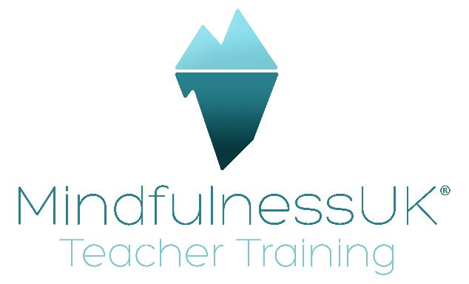

Meditation on Compassion and Tonglen (Giving and Taking) Practice
Tonglen is Tibetan for giving and taking. And is a meditation for developing compassion for one’s own suffering and that of others.
Usually, we dislike problems and want them to go away as soon as possible but it’s actually all about context and perspective. Think about how our household waste can become a nutritious compost for the garden, to help flowers, fruit and vegetables to flourish.
We have choices as to how we utilise these moments that could be seen as problematic, such as when we’re stuck in a traffic jam, we could get annoyed and frustrated or we could feel blessed to have time to do some practice, tune into how we’re feeling and so on.
Tonglen practice does just this, it transforms problems. In it we meditate on love and compassion, wishing ourselves and others to be happy and free from suffering, taking on our own suffering as well as that of others, transmogrifying it into happiness. We’re not becoming burdened with the suffering, it’s like switching on a light in the darkness, the dark doesn’t hide, it disappears instantly the light switch is flicked.
Breath awareness is an essential part of the practice, on inhalation we take in the suffering and its causes and whilst exhaling, sending happiness and goodness to others. It’s important to practice this on ourselves first, so that we’re ready to take on the suffering of others, having become familiar with doing this process on ourselves first. One can’t pur from an empty cup!
The practice involves imagining that we’re taking away the suffering of ourselves and others and sending out happiness. We’re not trying to take on the suffering of others in a martyrish kind of way, we are focused upon the others being free from their own suffering and acquiring happiness.
Sometimes with a focus upon our own suffering, we can feel that we are the only one feeling like tis or that our suffering is greater or more complex than that of others, becoming perhaps a little obsessed or overwhelmed by it, making it perhaps seem bigger than it is and having a sense of separateness. Again, it’s all about perspective-taking and by opening our hearts and being more compassionate, change often happens naturally.

The Practice
- Find the posture- upright, dignified, relax the body and mind into present-moment awareness.
- Pay attention to the breath for some time.
- Generate a positive motivation for the practice, setting your intention relating to the reasons why you are doing this practice in particular.
- Spend some time in contemplation around Maslow’s hierarchy of needs- we all need the basics, feel safe, loved, have friends, familiar possessions, home, a satisfying job, a wish to be free from suffering and pain etc.
- Touch into your heart and acknowledge that we all share these same needs that will ease our suffering and lead to happiness
Then…..
- Bring to mind a specific problem that is troubling you, on a scale of 1-10 around 4 or 5 is good. It might be physical, psychological or emotional. Feel the pain, sense into the suffering.
- Now, start to think of others you may know of or can imagine are feeling the same as you and have the same or similar problem to a greater or lesser degree. Generate a real sense of compassion for them, feeling how wonderful It would be if they were free from suffering.
- Decide that you will do this for yourself too, breathing in the felt sense of the suffering and breathing out a sense of calm abiding, allowing the mind to rest in a gentle, peaceful acceptance of it, feeling happiness pervade.
- Once your mind is stable, bring someone to mind in front of you that is suffering, really feeling their pain and suffering and how they have the wish to be free of this suffering. Feel how wonderful it would be for them to be free of their own suffering and develop a sense of courage to take their suffering into your heart that is bright with light. The bright, luminous energy of compassion transmogrifies the suffering into happiness which you breathe out to the person you’re imagining in front of you.
- If it’s helpful, you can imagine the suffering as thick, dark smoke coming out of the other which you bring into yourself, into your heart. As you breathe out, the suffering is no more and a bright light is sent to the other person, bringing with it joy, love, peace, happiness and all the well wishing to fill them with ease, fulfilling all their needs and wishes.
At the end….
Recall your motivation to do this practice and dedicate any positive energy that has been generated to the happiness of all beings.

